**Course Syllabus & Schedule**

**IT 150: Introduction to Networking**

LDS Business College Mission Statement:

To develop capable and trusted disciples of Jesus Christ

**This is a shared course with LDS Business College and BYU-Idaho. This syllabus is subject to change by the instructor. Please check I-Learn regularly. Also, there is LDSBC-specific language in this syllabus. If you are taking this course through BYU-Idaho, check the BYU-Idaho mission statement and university policies.**

**Instructor:**  **Semester:**

**Email:**   **Section:**

**Office:**  **Time:**

**Office Hours:**  **Room:**

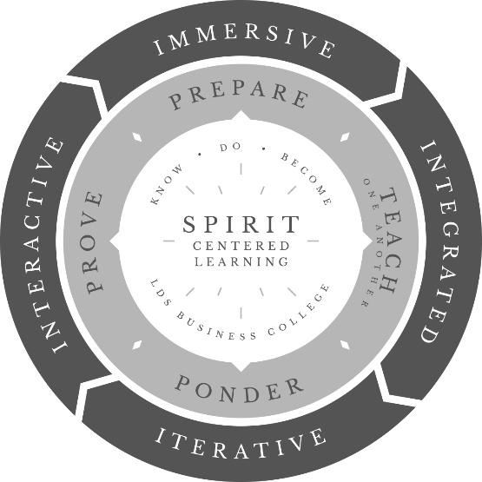

At the center of every LDS Business College or BYU-I classroom is deep, spirit-centered learning. Deep learning is the result of a learner acting in, with, and by faith in Christ.

Deep earning is best achieved through the four I’s of course design and the Learning Pattern. Deep learning leads to understanding—the capacity to know, do, and become—and is ultimately a gift of the Spirit.

**Catalog Course Description, Prerequisites, & Minimum Grade**

* Course Description: This course introduces the student to basic networking concepts including the OSI model, TCP/IP, networking services, and an exploration of wide area networks. It explores network security concepts including authentication, authorization, and security layers.
* Prerequisites: None
* Minimum Grade: A grade of C or better (not C-) in all IT and CS classes is required for graduation.

**Learning Resources**

* TestOut LabSim environment
  + The fees for this material are generally paid when the student registers for the course.
  + The LabSim license is good for 18 months from the date the LabSim course is activated.
    - For more information, please go to www.testout.com

**Assessment & Grading**

|  |  |  |  |  |  |
| --- | --- | --- | --- | --- | --- |
| **Grading Scale**  (total points earned divided by total points possible) | | | | | |
| **Score** | **Grade** | **Score** | **Grade** | **Score** | **Grade** |
| 94–100% | A | 80–83% | B- | 67–69% | D+ |
| 90–93% | A- | 77–79% | C+ | 64–66% | D |
| 87–89% | B+ | 74–76% | C | 60–63% | D- |
| 84–86% | B | 70–73% | C- | 0–59% | E |

|  |  |
| --- | --- |
| **Grading Components** | |
| **Assessment Activities** | **Points** |
| **Prepare:** TestOut Labs | **25%** |
| **Teach One Another:** Projects and Exercises | **25%** |
| **Ponder:** Practice Questions and Ponder and Apply | **10%** |
| **Prove:** Exams | **40%** |

**Capabilities & Learning Outcomes**

LDSBC cultivates a nurturing environment where practical skills are learned and discipleship is strengthened.

There are three types of outcomes guiding the curriculum at LDSBC. Students demonstrate the 1) College-Wide Capabilities, 2) Program Outcomes, and 3) Course-Specific Outcomes through the Learning Pattern as they *Prepare, Teach One Another, Ponder*, and *Prove* their knowledge, skills, and abilities. Course curriculum is immersive, integrated, interactive, and iterative.

Through this process, LDSBC graduates learn deeply and are prepared to contribute in their homes, communities, the Lord’s church, and in future employment.

|  |
| --- |
| 1. **College-Wide Capabilities**   To align with the mission of LDS Business College to develop capable and trusted disciples of Jesus Christ, the College is focused on helping learners demonstrate the following capabilities:  C:\Users\jwarnas\Downloads\CWC_1200x1200_gs.jpg**1: Teamwork and Leadership**  Create and sustain a culture of trust, vision, and continuous improvement that adds value to an organization.  **2: Communication**  Share information in diverse audiences, modes, and environments for the purpose of mutual understanding and edification.  **3: Technical Skills**  Demonstrate knowledge, skills, and abilities to accomplish specific tasks through proper systems, processes, and tools.  **4: Problem-Solving**  Analyze complex problems and generate creative solutions supported by informed evidence.  **5: Professionalism**  Exhibit behaviors reflecting a moral foundation of strong ethics and accountability. |

**2. Information Technology Program Outcomes for AAS degree**

Upon completion of the Information Technology Program, the student will be able to: (objectives that are bolded are specifically covered in this course)

1. Install and configure Windows servers.
2. **Demonstrate how to install and configure desktops, servers, and other networked devices.**
3. Design, document, and configure a relational database.
4. Analyze, model, and design a software application system.
5. **Configure a peer to peer network and configure a client-server network.**
6. **Describe the seven layers of the OSI model.**
7. **Demonstrate cybersecurity techniques including setting up a DMZ, configuring NAT, and configuring a firewall.**
8. Develop a simple program using current programming language.
9. **Prepare students to take industry certification exams.**
10. **Demonstrate proficiency through experiential learning and projects.**

**3. CITBC 150 Course-Specific Outcomes**

**Upon completion of CITBC 150, the student will be able to:**

1. Demonstrate an understanding of networking basics, networking topologies, the OSI model, and numbering systems.
2. Demonstrate how to use common command-line utilities to troubleshoot networking problems.
3. Demonstrate how to diagram a subnetted network using CIDR notation.
4. Demonstrate how to run a vulnerability assessment scan on a desktop or server.
5. Design a basic wireless network.
6. Demonstrate how to configure a basic firewall rule.
7. Exhibit professional behaviors reflecting a moral foundation of strong work ethic and accountability through posting and responding to Insight Sharing.

**Program & Course Policies**

* Late assignments will only be accepted up to one week past the deadline, and each late assignment will only be worth 50% of the original points possible.
* In order to graduate with an AAS degree in Information Technology, a student must receive a C grade or better (not a C-) in all IT classes

In addition, each course syllabus must include the following College Policies.

**College Policies**

**Email as the Official Method of Communication**

Official College messages to students are sent through LDSBC email. Students are responsible for all information received through their LDSBC email account. Students are expected to regularly check their LDSBC email accounts for official information from the College and their course instructors. This policy is to ensure that important LDSBC communication is received in a timely and consistent manner.

**Course Credit Hours & Classroom Preparation Time**

LDSBC measures academic credit in credit hours. In accordance with federal regulation, a credit hour at the College is the amount of work represented in intended learning outcomes and verified by evidence of student achievement that reasonably approximates not less than:

* One hour of classroom or direct faculty instruction and a minimum of two hours of out-of-class student work each week for approximately fourteen weeks for one semester hour of credit.
* An average student can expect to spend a minimum of two hours in outside preparation time for every hour in class. For example, in a 3-credit hour class, an average student can expect six hours of outside preparation time each week. This represents the average student who is appropriately prepared; more time may be required to achieve excellence.

**Copyright**

The course materials used in this class may be protected by copyright laws. Students are expected to make a good-faith effort to respect the rights of copyright holders. For more detailed information, please see the LDS Business College Copyright Policy. Students who disregard the policy may be in violation of the Church Education System Honor Code, may place themselves at risk for possible legal action, and may incur personal liability.

**Students with Disabilities**

Section 504 of the Vocational Rehabilitation Act of 1973 requires that reasonable modifications be provided for students with physical, cognitive, systemic, learning, and psychiatric disabilities. In order to receive modifications in the classroom, contact disability services (located within the Student Development Center) by emailing [DisabilityServices@ldsbc.edu](mailto:DisabilityServices@ldsbc.edu). or calling (801) 524-8151. Students must provide disability documentation and have a conversation with a disability services representative in order to determine what modifications are most appropriate for the student. Students receiving modifications will then receive a form to provide to their instructor.

**Honor Code Policies and Procedures & Academic Honesty Policy**

Students should be aware and review each semester the [Honor Code Policies and Procedures](https://www.ldsbc.edu/policies-and-procedures/policies-procedures.html) and the Academic Honesty Policy. The LDSBC learning environment and culture are created and preserved through commitment to personal conduct that reflects these ideals and principles. Adherence to these principles creates a community of saints where the Spirit may be in greater abundance.